# Installation

## XAMPP

XAMPP is an open-source software package created to provide an easy way for web developers to **install, configure and manage** necessary components to develop and run PHP-based web-based applications. The ultimate goal is to provide a full-fledged **local web server** to work on.

It contains four main components in a cross-platform (**X**) manner:

* **A**pache web server
* **M**ySQL database server
* **P**HP language
* **P**erl language

Besides, XAMPP also provides phpMyAdmin, MariaDB, FileZilla FTP server, Fake Sendmail, Mercury Mail server, JSP server Tomcat, Webalizer.

For more details, check following posts:

* How to install at [here](https://pureinfotech.com/install-xampp-windows-10/#install_xampp_windows10).
* How to configure at [here](https://pureinfotech.com/install-xampp-windows-10/#configure_xampp_windows10).

## Composer

Composer is the most popular **dependency manager for PHP**. We'll use it to install Laravel framework and many necessary dependencies for PHP-based webs/applications.

* How to install at [here](https://getcomposer.org/download/).
* Common CLIs at [here](https://getcomposer.org/doc/03-cli.md).

**Note**: Composer automatically add itself and PHP to the PATH environment variable.



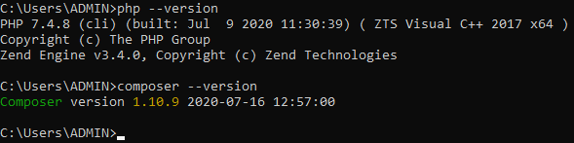

## Laravel Framework

Throughout this tutorial, we'll use Laravel – the most famous and popular PHP framework – to make web-based applications.

For how to install it, check [here](https://laravel.com/docs/7.x#installing-laravel).

# Welcome Page

Laravel always include a default project with welcoming message to their framework once we install it. We'll create this project, name it welcome and put in the htdocs directory of XAMPP (e.g. C:\xampp\htdocs).

**1.** Run following commands to create the welcome project:

cd C:\xampp\htdocs

composer create-project --prefer-dist laravel/laravel welcome 5.7

**Note**:

* Here we use composer and specify version 5.7 for Laravel. If you want to install the latest version, just remove 5.7 from the command.
* The command not only creates the new project but also pull all source code, dependencies and configurations of Laravel from Github.

**2.** Start Apache server from XAMPP control panel using the default ports:

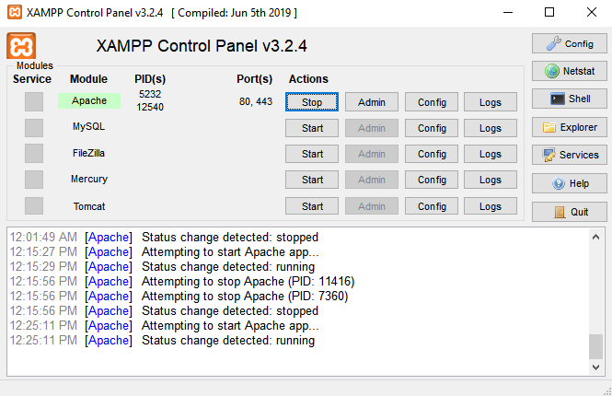

**3.** Now we can open the welcome's main page by running the following URL in the web browser:

localhost/welcome/public

**Note**: Here localhost is our local web server (we can change it to 127.0.0.1) and welcome is the name of the project. We also need to add public at the end.

Here is the result:

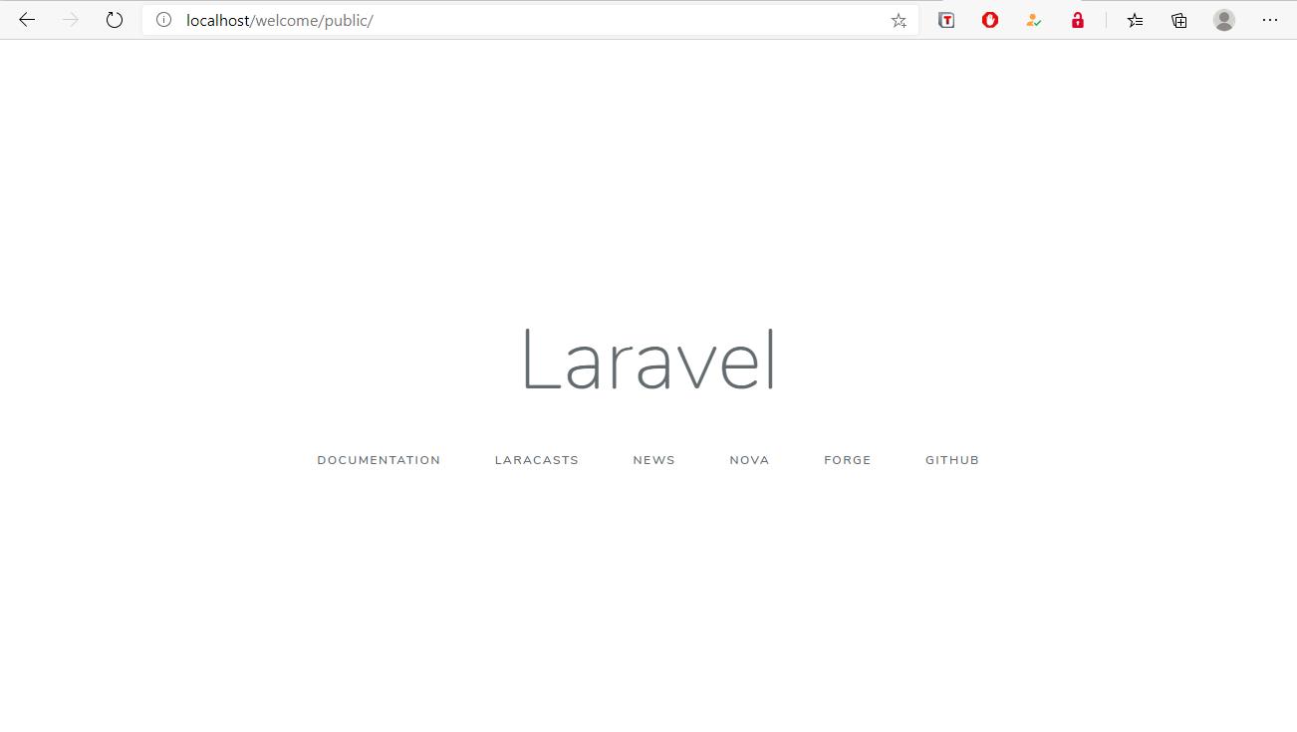

**Warning**:

If you forget to start Apache web server, you'll get:

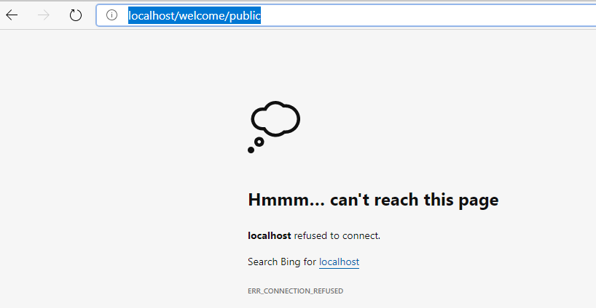

If you started Apache but forget to put welcome project to htdocs, you'll get:

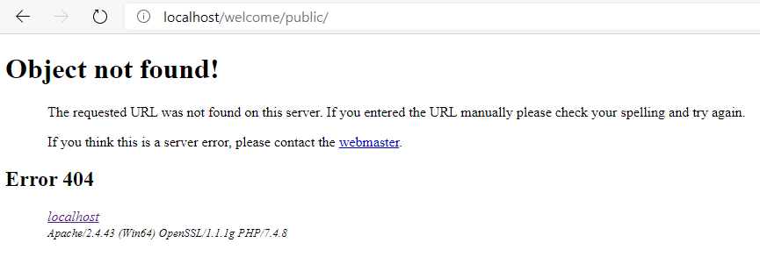

If you forget to add /public, you'll get:

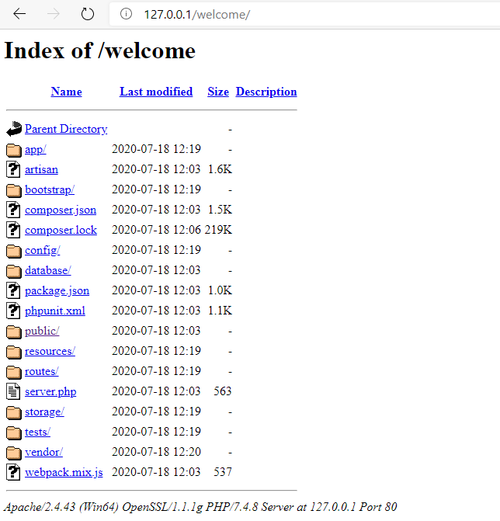

# Directory Structure of Laravel

<https://www.studentstutorial.com/laravel/hello-world>

# Artisan CLI

<https://laravel.com/docs/7.x/artisan>